Session State

* Used to save and store user data while user browses your web app. Consisting of dictionary or hashtable on the server , session state persists data across requests from browser. The Session data is backed by a cache.
* ASP.Net Core maintains session state by giving a client a cookie that contains SessionID which is send to the server with each request.

Server uses Session ID to fetch data.

* Session cookies are deleted only when the browser session ends.
* Server retains a session for a limited time after the last request, you can set the session timeout or use the default value 20 min.

Demo : How to Work with Session

1. Add Support for Session

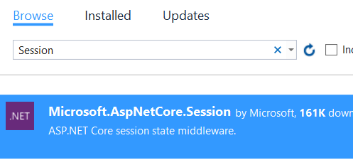

1. Add MVC Support

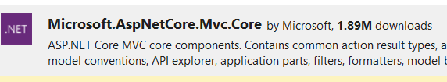

1. Add MemoryCache and Session code in StartUp.cs

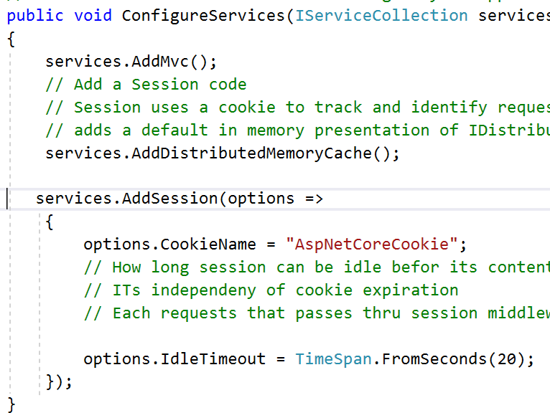

1. Add HomeController with couple of method and write a code to store data in Session

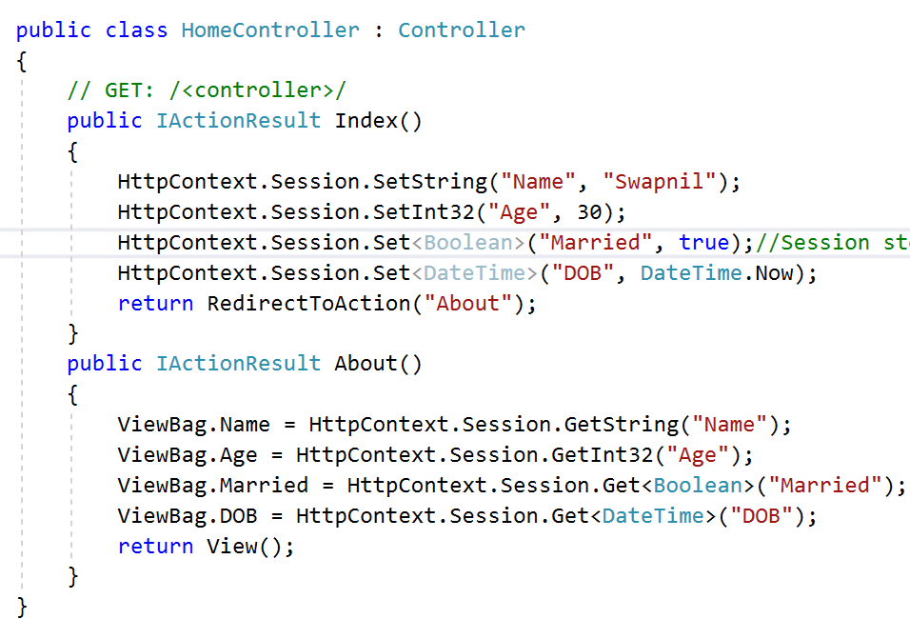

1. Session Store data as Byte Array . To store complex object you need to add SessionExtension class which is helper class for such kind of storage

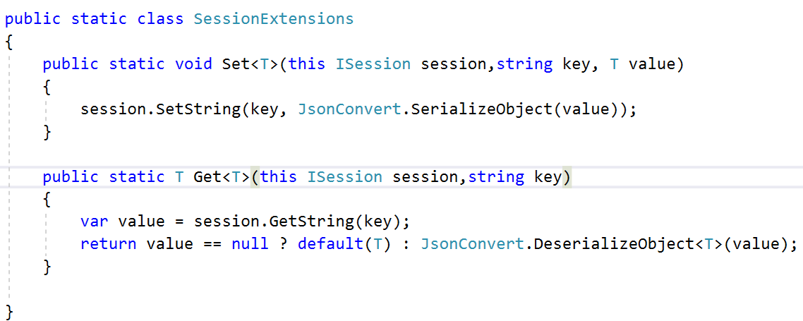

1. Check the Output
2. How to Store same data in SQL Server
3. Add SqlServer support



1. Add Package Ref in .csProj



1. Open Command Prompt and write a command to create table

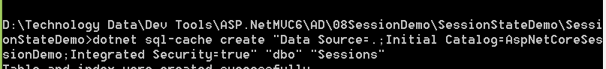

1. Check the Output .. Data will be stored in SQL Table